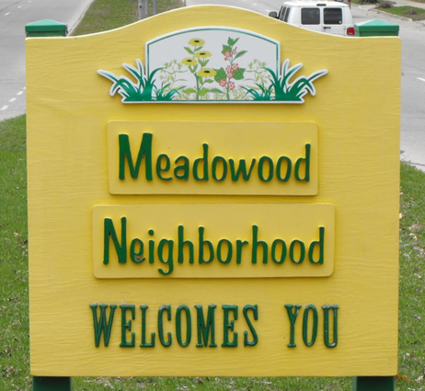

On behalf of the Meadowood Neighborhood Association, we would like to welcome you to your new home! In this packet are a few things that we hope will be helpful in making you become familiar with our community and feel at home.

We believe that involved neighbors are great neighbors and so we hope that you will feel welcomed and ready to meet others in the community and get involved with events happening in the area! If you are interested in becoming a part of MNA, please feel free to contact _______________________________________________.

Community events and activities are funded through annual dues and we are proud to say that these dues have not changed in over 20 years! Members of MNA enjoy events to grow community, open access to all MNA meetings, newsletters and much more for only $5 per year. As our gift to you, we would like to offer you a free one year membership! Simply fill out the attached membership card with you name and return it to _______________________________.

Please visit our website http://www.meadowoodneighborhood.org to learn more about MNA and your new neighborhood!

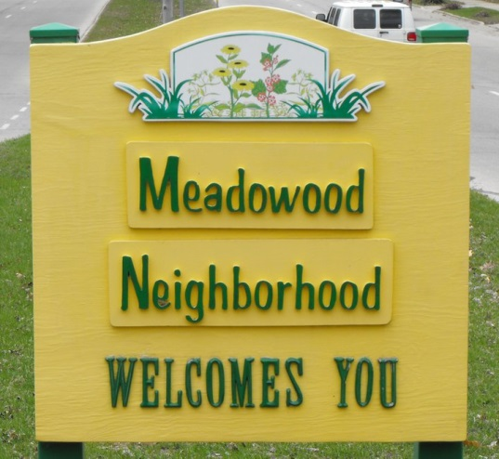

Meadowood Neighborhood Association
The Meadowood Neighborhood Associoation is here to help you! Please contact us via our website: http://www.meadowoodneighborhood.org or on our Facebook Page: https://www.facebook.com/Meadowood.Neighborhood.Association

You are in area ________________

Recycling/Trash
Trash collection happens weekly on either Tuesday or Wednesday
Recycle collection happens bi-weekly on either Tuesday or Wednesday
For more information on yard waste collection, hazardous material disposal and large item pick-ups go to:
https://www.cityofmadison.com/streets

Winter Alternate Side Street Parking
During Winter months, Madison uses and Alternate Side Street Parking program to help the streets division clear away snow, from November 15 – March 15 park on the even numbered side of the street on the even days and the odd numbered side of the street on odd days. For more information and to learn about winter parking go to:
http://www.cityofmadison.com/residents/winter/parking/alternateSideParking.cfm

Non-Emergency Police Number
*For any and all emergencies; including Police response, Fire or Medical Emergencies; please dial 9-1-1
Non-Emergency Dispatch: (608)255-2345
Madison Area Crime Stoppers: (608)266-6014
For more information go to: http://www.cityofmadison.com/police/contact/contact.cfm

Grocery Stores Near You
Woodman’s West:
Chain of full-service supermarkets (some with movie rentals & gas-station services).
Address: 725 S Gammon Rd, Madison, WI 53719
Phone:(608) 274-8944
Hours: Open 24 hours

HyVee Madison #2 (Whitney Way):
Hy-Vee's west side store, on the corner of Odana Road & Whitney Way.
Address: 675 S. Whitney Way Madison, WI 53711
Phone: 608-277-6735
Hours: Open 24 Hours

Libraries Near You
Meadowridge Public Library
Address: 5726 Raymond Rd, Madison, WI 53711
Hours: Monday – Friday 10AM–8PM
Saturday 9 AM-5PM
Sunday Closed
Phone: (608) 288-6160

Parks Near You
Meadowood Park
Address: 5807 Thursh Ln
Open Daily until 10 pm

Elver Park
Address: 1250 Mckenna Blvd
Open Daily until 10 pm

Huegel Park
Address: 5902 Williamsburg Way
Open Daily until 10 pm

Western Hills Park
Address: 2401 S. Whitney Way
Open Daily until 10 pm

COMMUNITY HEALTH WORKER

Have a health concern? Wondering what community resources are available to help you? Sheray Wallace, the first community health worker in Dane County, is here to help! All services provided by the community health worker are free and open to all community members.

Schedule: Open Wednesdays 10am-4pm and Fridays 10am -1pm
Location: This FREE service is located at the Meadowridge library

JFF Location & Contact
Joining Forces for Families (JFF) is a voluntary, community-based, supportive service that helps families address their basic human needs. By quickly linking clients to resources, JFF often keeps families stable and deflects them away from costly formal system interventions.

Office Address: 5810 Russett Road #1
Madison WI 53711
Contact: Michael Bruce
Phone: 273-6622
Fax: 273-6624
Email: bruce@countyofdane.com

GOOD SHEPHERD FOOD PANTRY
Raymond Rd. & Whitney Way
5701 Raymond Road
Madison WI 53711
Hours: Thursdays, 10am – Noon, 5:30pm – 7pm

To receive food assistance: The pantry provides emergency food assistance to residents in the 53711 or 53719 zip code areas. Guests receive approx. 2 days of groceries per household size and may receive food every four weeks. Please bring an ID for each member of your household and any document that would verify your address and zip code.

To volunteer or to ask questions about donating food:
Please e-mail Pastor Sheryl Erickson at serickson@gslcwi.com.

Meadowridge Library – Personal Hygiene Supplies

Meadowridge Library has a variety of personal hygiene supplies available free of charge. Supplies vary but the following are always available: condoms, a variety of tampons, pads, and deodorant. Various size disposable diapers and wipes may be available at certain times.

To obtain personal care items, ask a library staff member. A free backpack will be supplied to carry the items home.

Meadowridge Library accepts donations of toiletries all the time. Bring donations to the front desk.
This program is only available at Meadowridge Library.

